OBJECTIVE

To perceive a career in a renowned firm with dedicated efforts and to effectively utilize the knowledge gained in my academic curriculum & from life for attaining a responsible, challenging and rewarding position

SKILLS

Basic: MS OFFICE,
Internet.

Programming Languages:
python,
JavaScript,Django,Flask

Web Programming: HTML, PHP, Java Script, Css wordpress.

Hosting: AWS,digital
ocean,godady.

Database: MySQL, DBMS.

Extra Qualification : Diploma in Computer Application ,

Good knowledge in computer hardware parts also.

NOOR ALAM
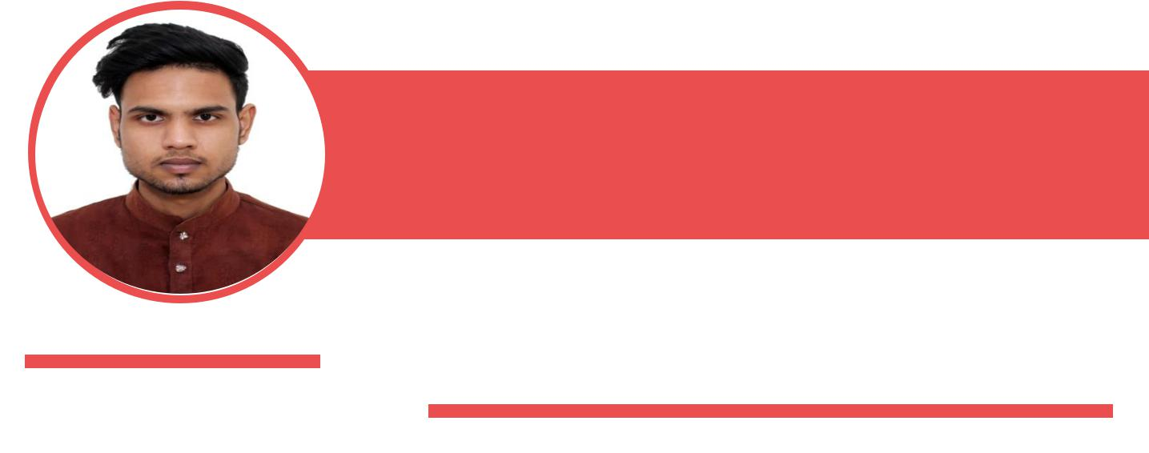

MAIL ID:- NOOR.ALAM.619@GMAIL.COM|

ADDRESS: -OKALA VIHAR SOUTH DELHI| PHONE:7903350593

EXPERIENCE

INTERNSHIP • AAM ADMI PARTY IT DEPARTMENT FROM 06/06/2019 TO 06/08/2019-

Working as it intern in development of software application. Made app automation and also help in managing database

INTERNSHIP • RURALSHORES SKILLS ACADEMY • 15/08/2020

– TO 30/9/2020

Working as a web developer created a website and managing the database work. Also covering the ecommerce site

INTERNSHIP• JET SET CAREER(remote) • 02/10/2020

– TO TILL NOW

Working as a web developer and backend developer

Full Time Job• BlockAudit • 01/8/2021

– TO TILL NOW

Working as front-end developer (react.js)

EDUCATION

CLASS 10TH • 2014 • J.L.N SENIOR SEC. SCHOOL

Board:-C.B.S.E

CGPA:-8.0

CLASS 12TH • 2016 • D.A.V SEC-4

BOARD:-C.B.S.E

PERCENTAGE:-65%

Graduation in BCA • 2020 • IIMT Greater Noida

University:-CCS university PERCENTAGE:-68%

VOLUNTEER

Worked in 2 NGO as volunteer helped in teaching poor kids in Umeed Ngo and Rise the funds for India Redefined






NOOR.ALAM.619@GMAIL.COM 7903350593 NOOR-ALAM-AA722314B GITHUB.COM/NOORSHANU

